GET vs POST :

HTTP protocol supports several methods using which a web client can access a web server.

GET is the default method that will be used if no method is explicitly specified.

When we are fetching data – the good way is to use GET method.
POST is meant for posting data to the server.

We shouldn't use GET method when sending sensitive data to the server.

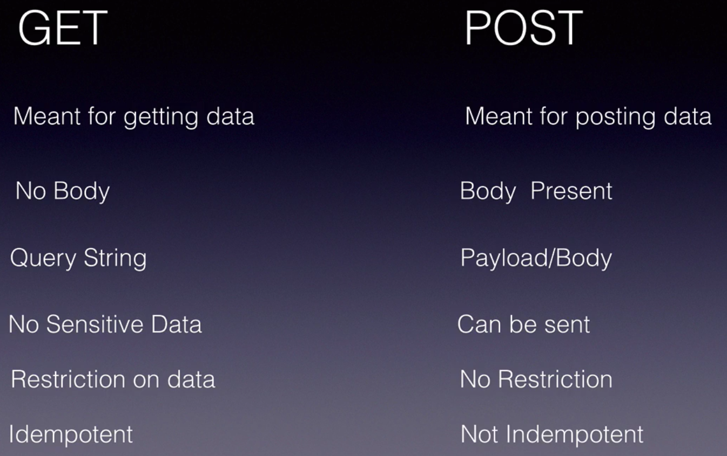
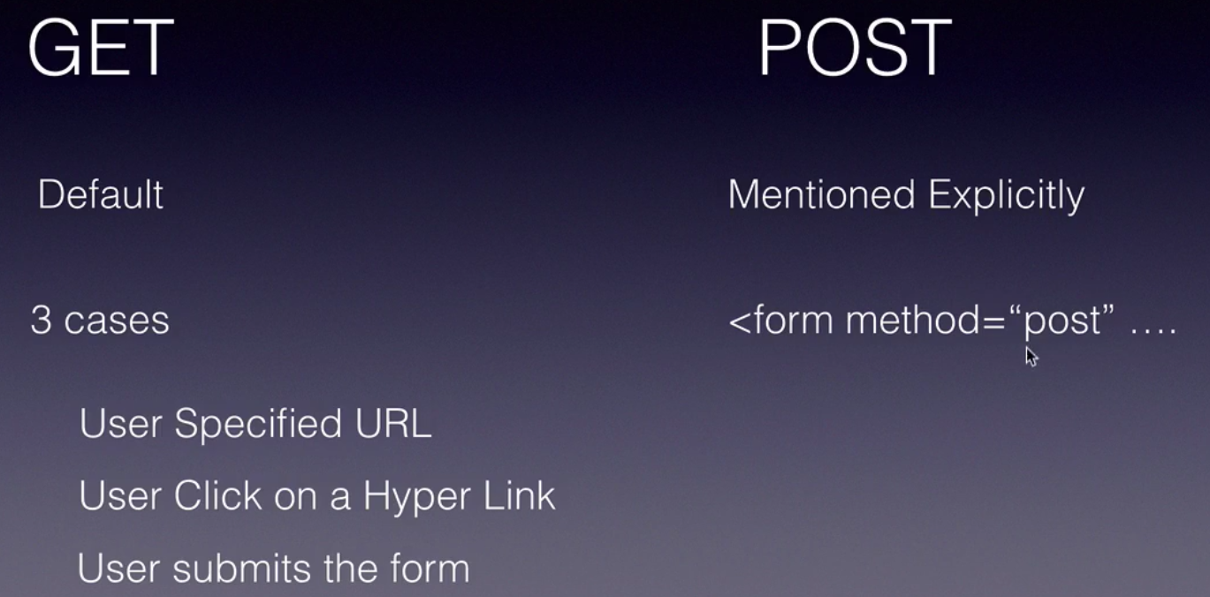

Create a new Dynamic web project named 'UserDynamicWebApp'.
Create user table in MySQL DB like this :

use mylocaldb;
create table user (firstName varchar(20), lastName varchar(20),
email varchar(20), password varchar(20));
select * from user;

@WebServlet("/addServlet") -> this creates a Servlet and adds a URI mapping.

Check the code example : UserDynamicWebApp project. It has CRUD operations that interact with DB from Servlet.

